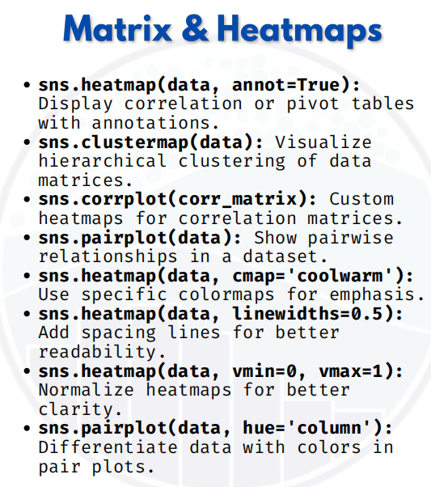

MATRIX & HEATMAP

1. sns.heatmap(data, annot=True)
Used to display correlation or pivot tables with annotation (values inside cells).
import seaborn as sns
import matplotlib.pyplot as plt
import pandas as pd

# Sample correlation matrix
data = pd.DataFrame({
'Math': [88, 92, 80, 89, 100],
'Science': [95, 85, 76, 88, 92],
'English': [78, 90, 85, 80, 86]
})
corr_matrix = data.corr()

# Heatmap with annotations
sns.heatmap(corr_matrix, annot=True)
plt.show()

2. sns.clustermap(data)
Visualizes hierarchical clustering of rows & columns.
sns.clustermap(corr_matrix, annot=True, cmap="coolwarm")
plt.show()

3. sns.corrplot(corr_matrix)
sns.corrplot doesn’t exist directly in Seaborn — it’s usually done with
sns.heatmap(corr_matrix).
So, this is basically a custom correlation heatmap.

sns.heatmap(corr_matrix, annot=True, cmap="YlGnBu")
plt.title("Custom Correlation Plot")
plt.show()

4. sns.pairplot(data)
Shows pairwise relationships in a dataset.
sns.pairplot(data)
plt.show()

5. sns.heatmap(data, cmap='coolwarm')
Change colormap for emphasis.
sns.heatmap(corr_matrix, annot=True, cmap="coolwarm")
plt.show()

6. sns.heatmap(data, linewidths=0.5)
Add grid spacing lines for readability.

sns.heatmap(corr_matrix, annot=True, linewidths=0.5)
plt.show()

7. sns.heatmap(data, vmin=0, vmax=1)
Normalize values to fit within a range.
sns.heatmap(corr_matrix, annot=True, vmin=0, vmax=1, cmap="Blues")
plt.show()

8. sns.pairplot(data, hue='column')
Differentiate groups using colors.
import seaborn as sns
from sklearn.datasets import load_iris
import pandas as pd
# Iris dataset
iris = load_iris(as_frame=True)
iris_df = iris.frame
# Pairplot with hue
sns.pairplot(iris_df, hue="target")
plt.show()

